# **User Scenario: The Characters**

**1.1 The Target User**

The audience for outdoor hiking and trail exploration is influenced by various factors such as the age, fitness level, trail difficulty, interest in nature exploration, etc. Trail Seek is a platform designed to provide trail information for people who want to explore nature and connect to people by hosting user organised events.

The app is designed to target tourists and locals who are interested in exploring various trails across Ireland. The data collection for target audience was done through stakeholder interviews, surveys and research.

Although research suggests that the mean age of users who are active hikers is 22 and above (Hamonko et al., 2011; Kelley et al., 2016), mobile applications are used by children as young as 4 (Kabali et al., 2015). Although mobile application usage starts at a very early age, nature related activities such as hiking, trail running, trail biking, etc account for only 5.4% out of all the outdoor activities among children between the age of 6-19. This suggests that the primary user of our application who will browse and explore the trials is above the age of 22.

In Ireland, there has always been a demand for trial-based activities, so much so that there is a willingness to travel and pay to access the trails (Kelley et al., 2016) and studies have shown that tourism is also affected positively when the ecosystem around trails is improved (MacLeod, 2017). Since the app also has event hosting capabilities, it can be used as a platform for hosting.

Base on the above research we have concluded that the target audience for our app is:

* Adventurers: People who are interested in adventures and group activity.
* Organizations: Organizations such as a university hosting a hike for freshers.
* Charitable trusts: Hosting a fundraising outdoor event.
* Tourists: Introduce the city to tourists who are looking for an outdoor adventure. and at the same time interact with the locals.
* Age group 22 and above.

User Personas :

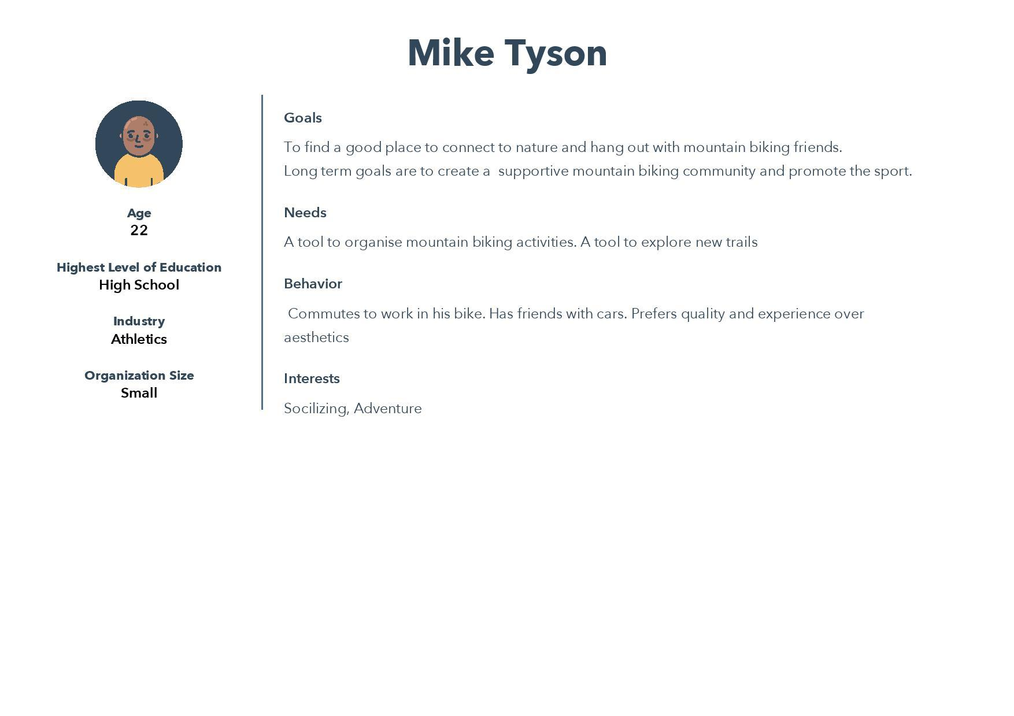

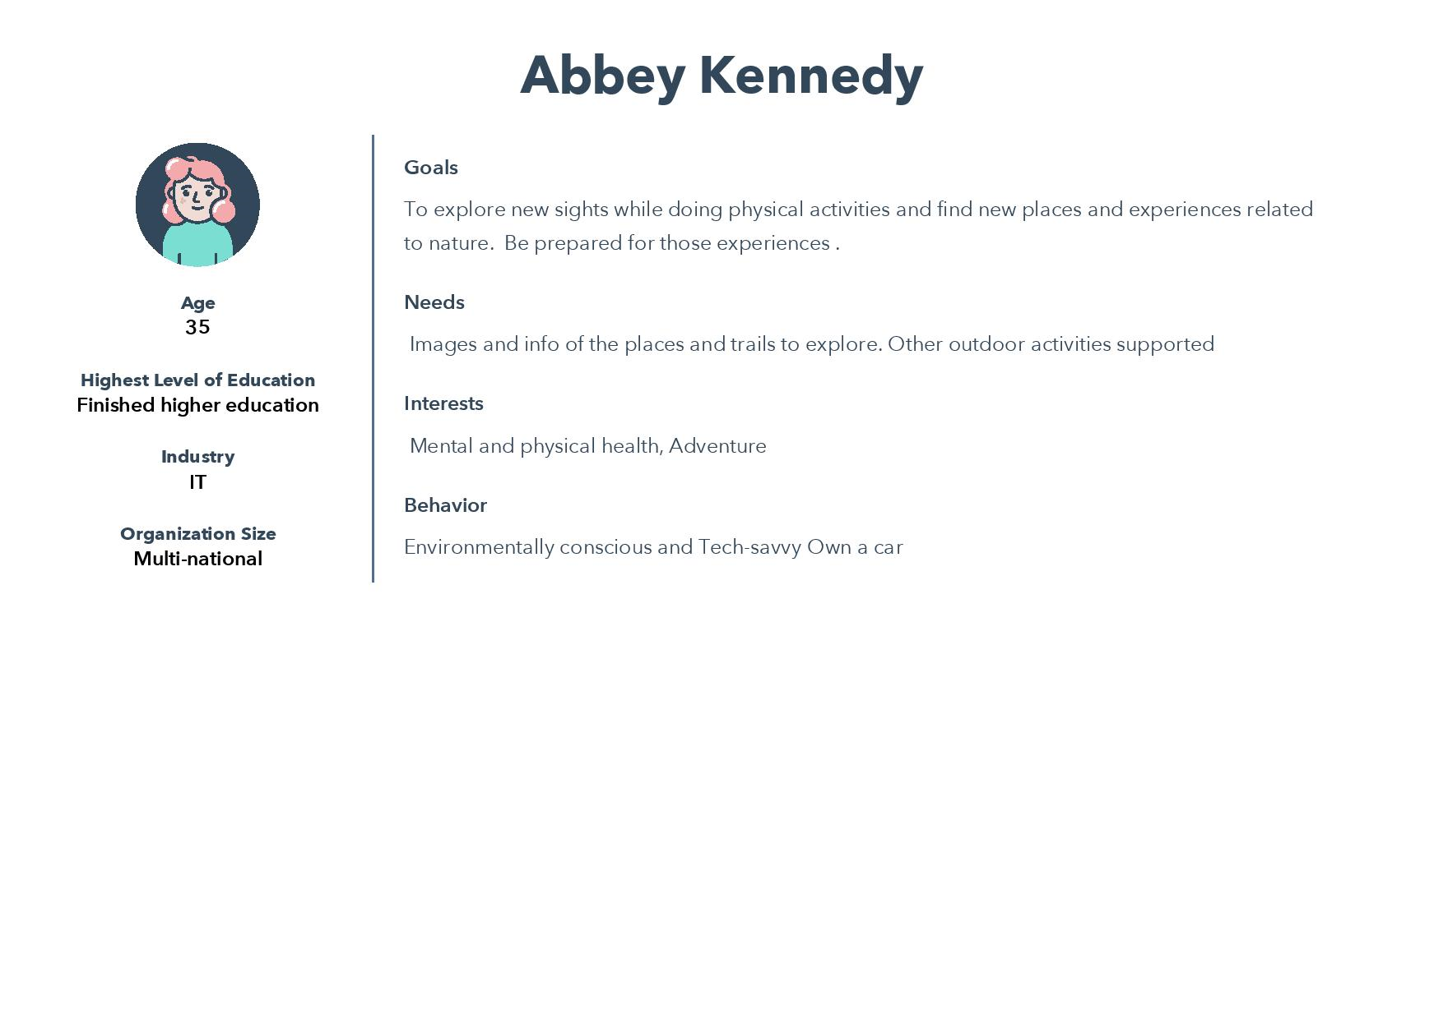

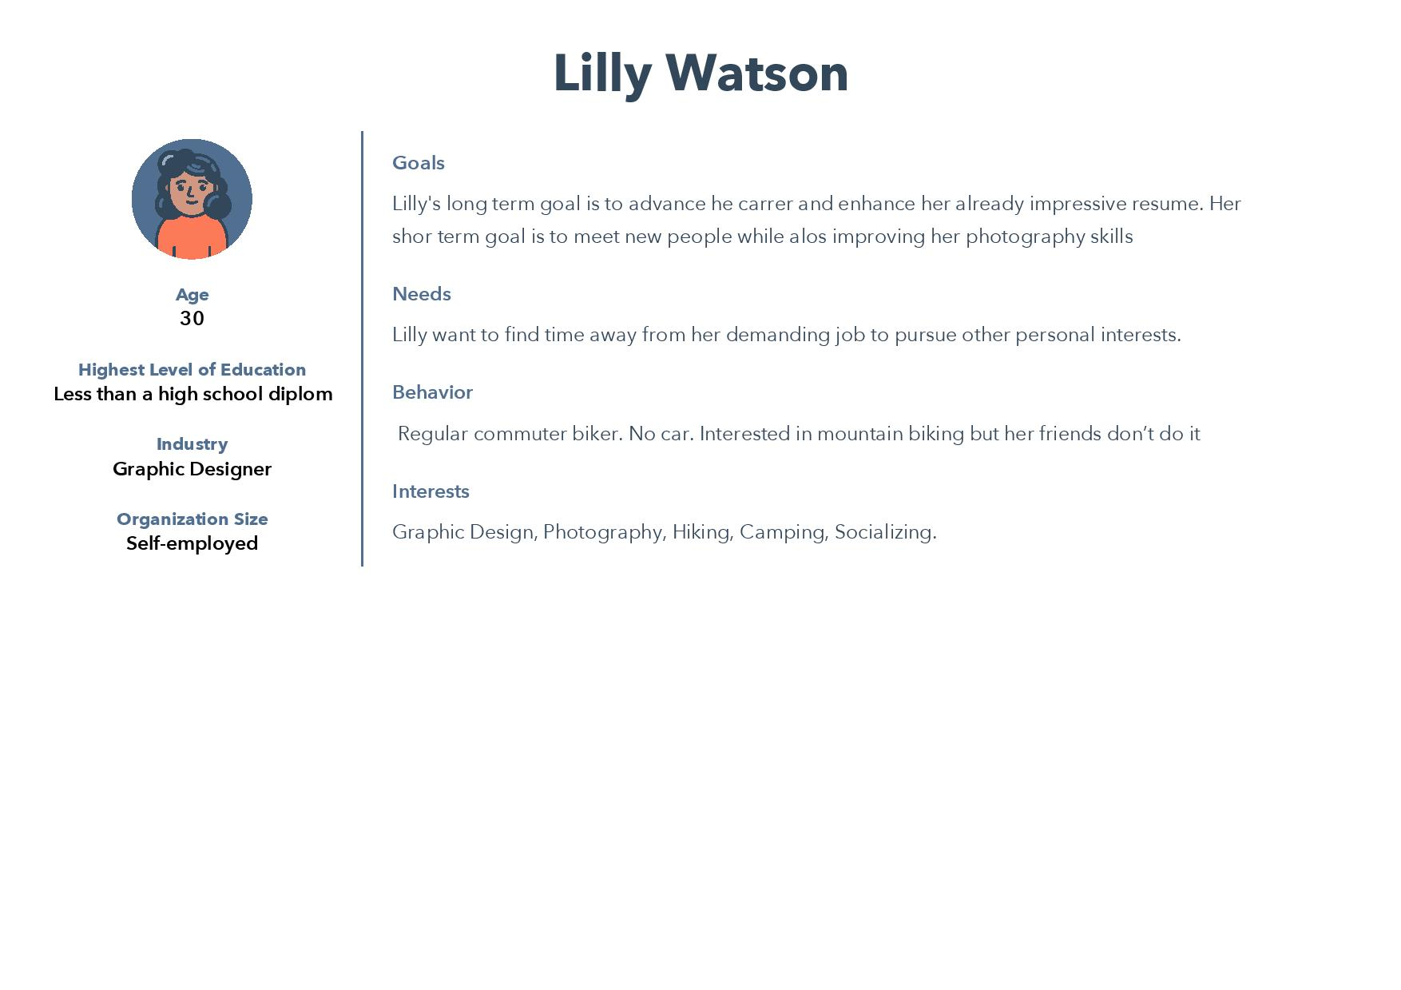

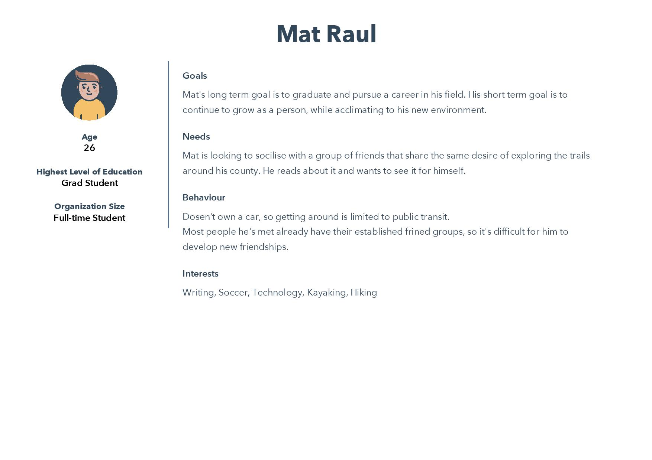

**1.2 The importance of Target Users**

A survey was conducted to gauge the interest of the target audience of our proposed system.

Link to the survey: <https://docs.google.com/spreadsheets/d/1XYTy-t_tKd2iNrYW27kAk2iQU1_N5u9RPXAHy3PvLaI/edit?usp=sharing>

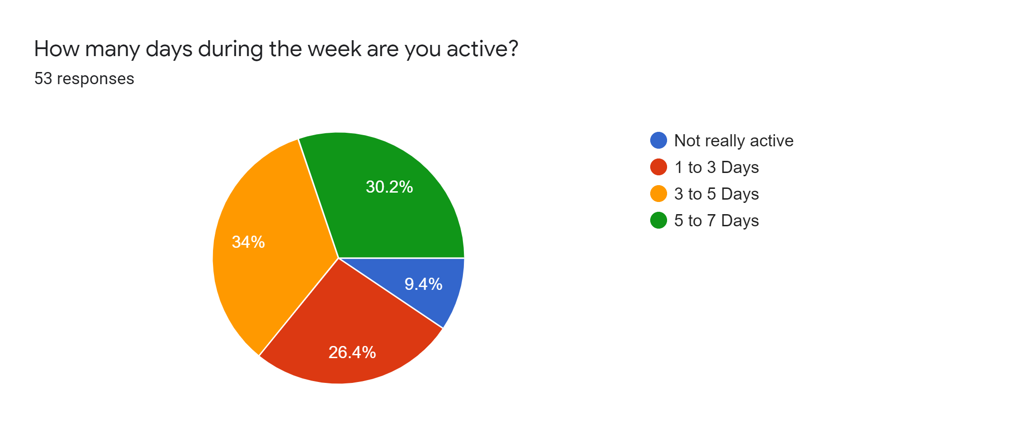

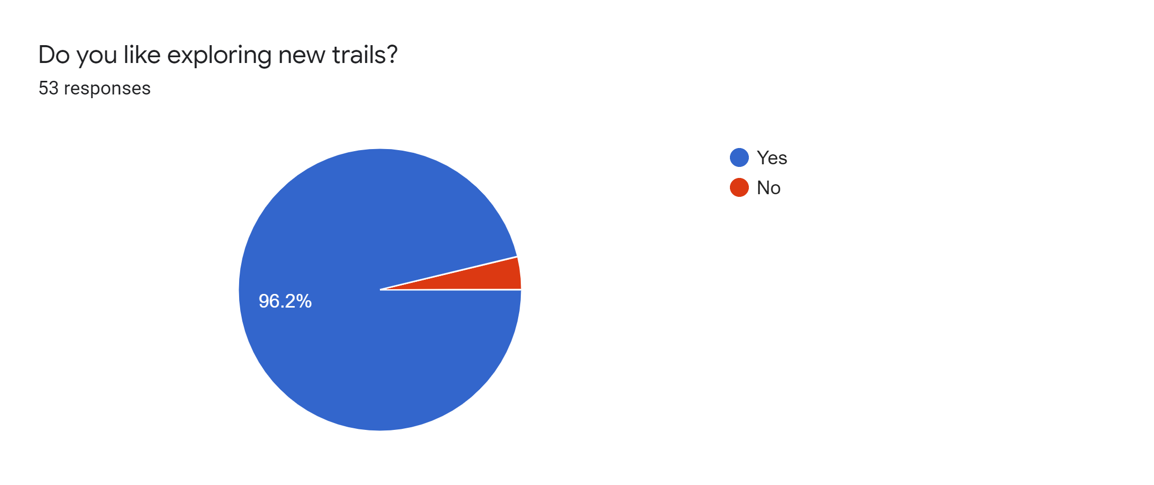

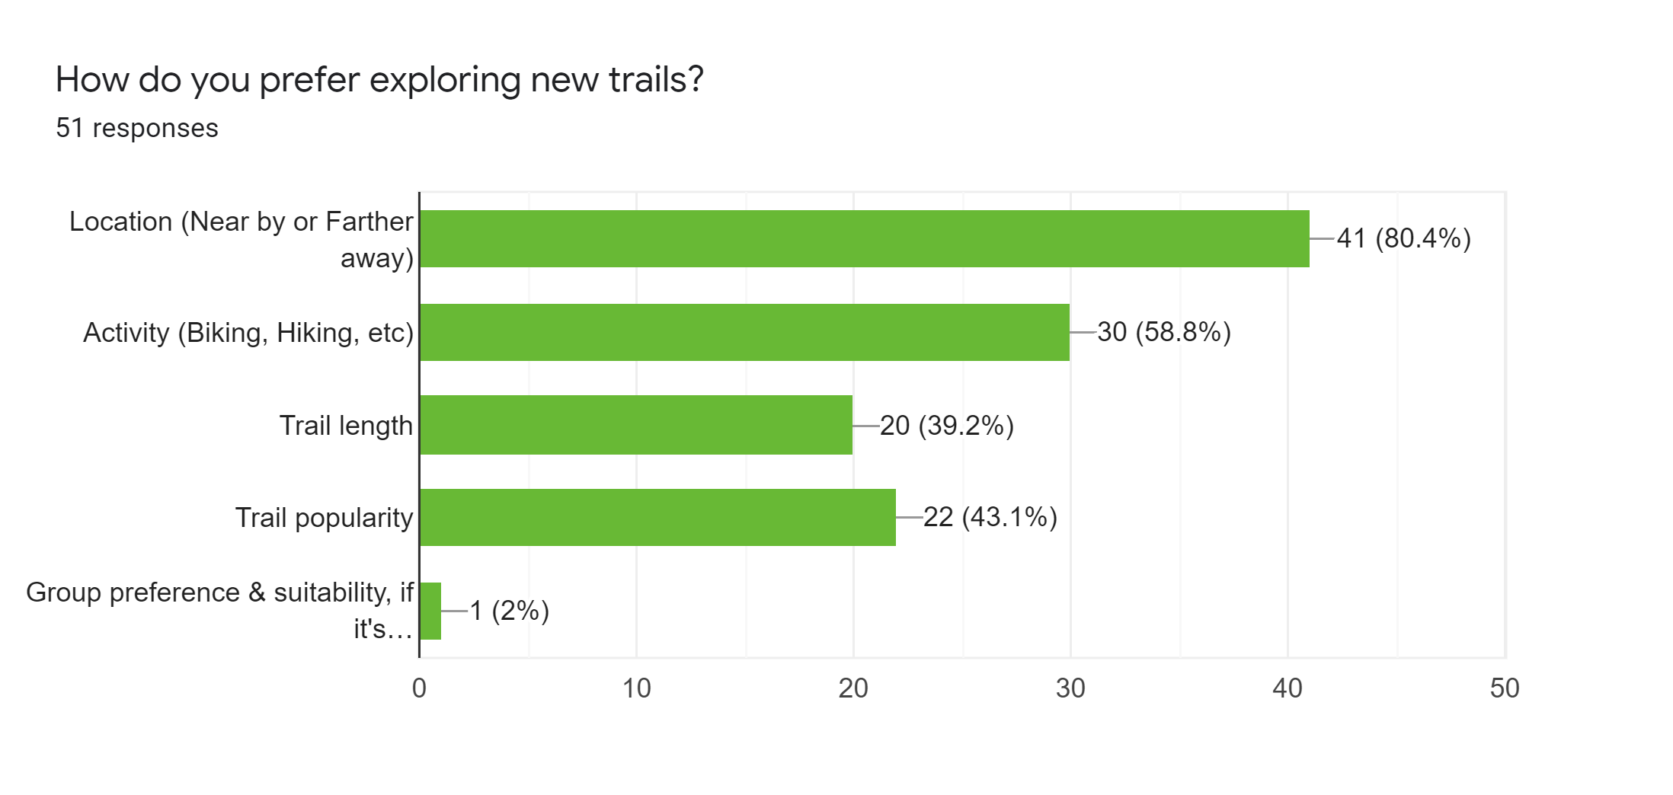

Responses from the survey suggested that most of the people were active for more than 3 day a week and there was a significant interest in trail exploration. These results were expected as there are applications out there which meet these demands.

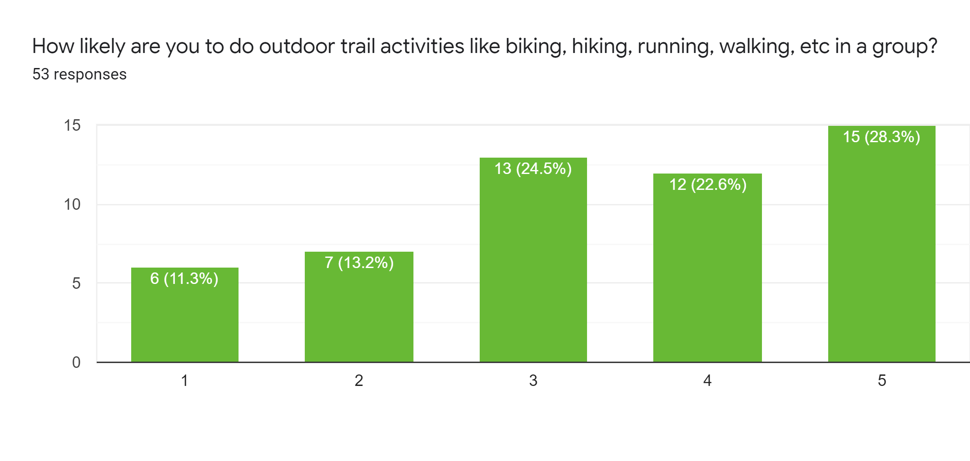

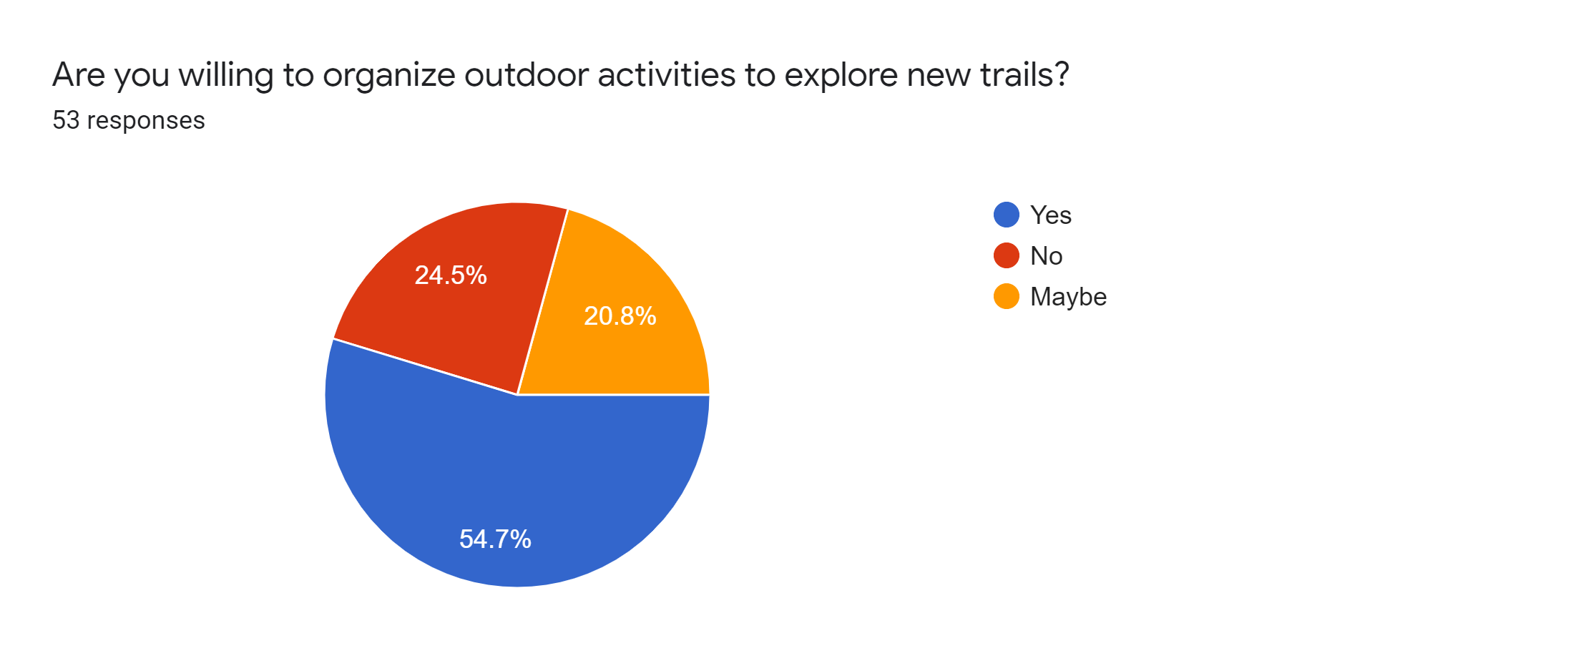

The important factor for us here is the fact that there is an interest in group activities and willingness to host outdoor activities which is one of the core components of our proposed system i.e Events.

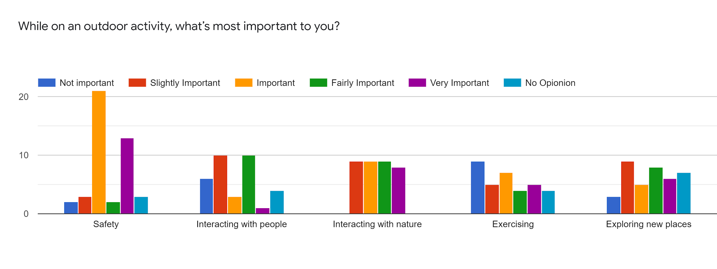

Here we got a gauge of potential features and additional functionalities that could be added in our application. For eg. An importance in exercising suggests a potential of adding an exercise summary at the end of a trail.

**1.3 The problems solved for the user**

The above data makes it clear that there is a demand for trail exploration in a group environment. Our platform aims to solve that demand by having trail exploration smoothly integrated into group events.

Choosing a mobile application instead of a responsive website has significant advantages. There is a more streamlined access to the device's sensors like GPS. Studies have shown that upto an hour is spent on mobile applications alone each day (Bohmer et al., n.d.) and having a native mobile application typically gives a better user experience (Charland & Leroux, 2011).